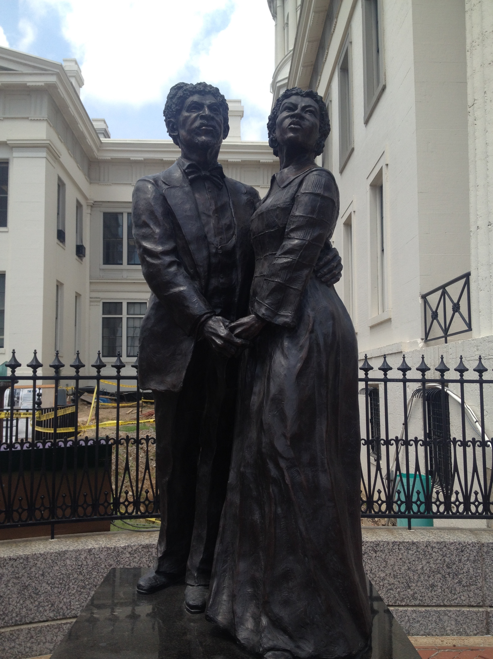
Slavery in Politics

2. Dred Scott and his wife.
1. John Brown-Kansas mural
1. Kansas-Nebraska Act of 1854- Most of the Western territories used ‘popular sovereignty,’ (created by Sen. Stephen A. Douglas) or “let the people decide” whether a place was slave or free. These led to violent conflict between anti-slavery and pro-slavery people in the Kansas and Nebraska territories (“Bleeding Kansas” and “Sack of Lawrence”) in 1856. Abolitionist John Brown fought in Kansas, and later attacked an armory at Harpers Ferry, VA (now West Virginia). Kansas was admitted as a free state in 1861.

2. Dred Scott Case-1857
Dred Scott, a slave, tried to sue for his freedom. He claimed he was free when he traveled with his master to Illinois and Wisconsin (before moving back to slave state Missouri). Scott’s lawyers appealed the Dred Scott vs. Sandford to the U.S. Supreme Court. However, Supreme Court chief justice Roger Taney ruled that all African Americans, whether they were free or slave, were not citizens. As a result, they could not sue for freedom. This case overturned the Missouri Compromise (1820), allowing slavery in the Western territories. This case angered abolitionists nationwide.
3. Lincoln-Douglas Debates-1858
As the arguments over slavery intensified, people running for office used slavery as their platform, or main issue. In Illinois, for example, Sen. Douglas (Democrat) and a then-unknown Abraham Lincoln (Republican) held multiple debates on whether or not to allow slavery in the Western territories. Douglas was campaigning to keep his senate seat, while Lincoln challenged him. Lincoln lost the 1858 election, but defeated Douglas in the 1860 presidential election.

Lincoln in 1858 on the U.S. on the issue of slavery: ”A house divided against itself cannot stand.” I believe this government cannot endure, permanently half slave and half free.
3. Lincoln-Douglas debates statue

