Plymouth Rock Colony
- English pilgrims seeking religious freedom left Europe in 1620 for what is now Plymouth Rock (Mass.) on the “Mayflower”
- They were originally headed for what is now New York City, but got moved around by bad weather and ended up in Plymouth Harbour.
- The Pilgrims wrote and signed a Mayflower Compact, which promised self-government, or an early democracy (just like today’s U.S. government)
- A harsh winter kept the pilgrims inside their ship; roughly half of the 100-plus people who came died (illness)
- Squanto and the Wampanoag Indians helped the pilgrims farm, hunt, and fish
- They celebrated their survival and good relations with a three-day feast=First Thanksgiving!
- Supposedly no turkey, though, but goose, lobster, and deer!
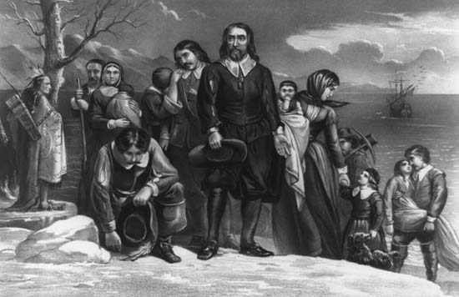
- William Bradford-first governor of the Plymouth Colony

Photo courtesy of kids.britannica.com

Please draw and complete a Venn Diagram comparing the Jamestown and Plymouth Rock colonies (below or on a separate sheet of paper)
Mayflower Compact |  |  | English pilgrims, after stopping at modern-day Plymouth Rock, created a document for the first Western democracy
William Bradford |  |  | Governor of the Plymouth Rock colony (1620)
Squanto |  |  | English-speaking Indian who helped the pilgrims colonize after first winter

