Piedmont Region
- Piedmont Region-An area known for its red clay and hilly locations, located at North Carolina’s center and is the most populated
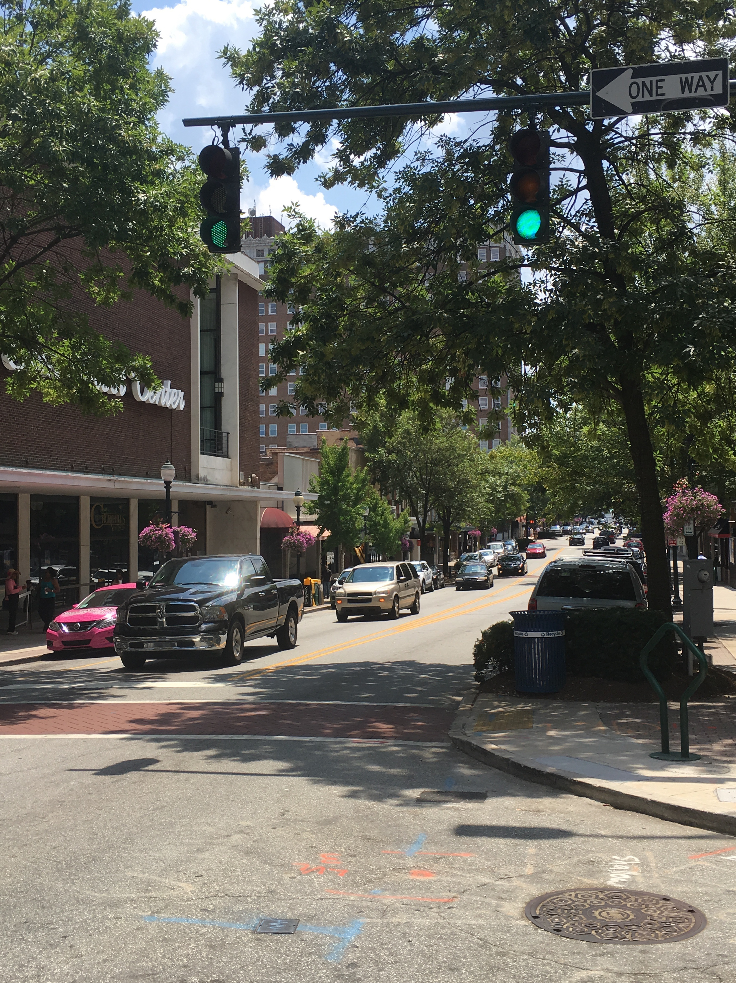
- Picture below: Downtown Greensboro
- Interesting fact: To control the red clay erosion, the state planted millions of kudzu plants (that backfired---it’s now a well-known North Carolina weed)
- Two main rivers in the Piedmont: Catawba and the Yadkin Pee-Dee—one area of hills has a monadnock, or “last mountain standing” due to erosion (Pilot Mountain)
- There is occasional farming, but there are more livestock and dairy farms
- Tobacco manufacturing (Durham), textiles (Winston-Salem), and furniture making (High Point) grew in the 1800s; this state was once the nation’s leader in all three
- People who lived near the factories lived in mill villages, owned by the companies who hired them
- In recent years the Piedmont region has lost a lot of textile and furniture-making businesses
- Despite lost manufacturing jobs, the region has recovered with banking (Bank of America), racing (NASCAR), and medicine (Research Triangle)

