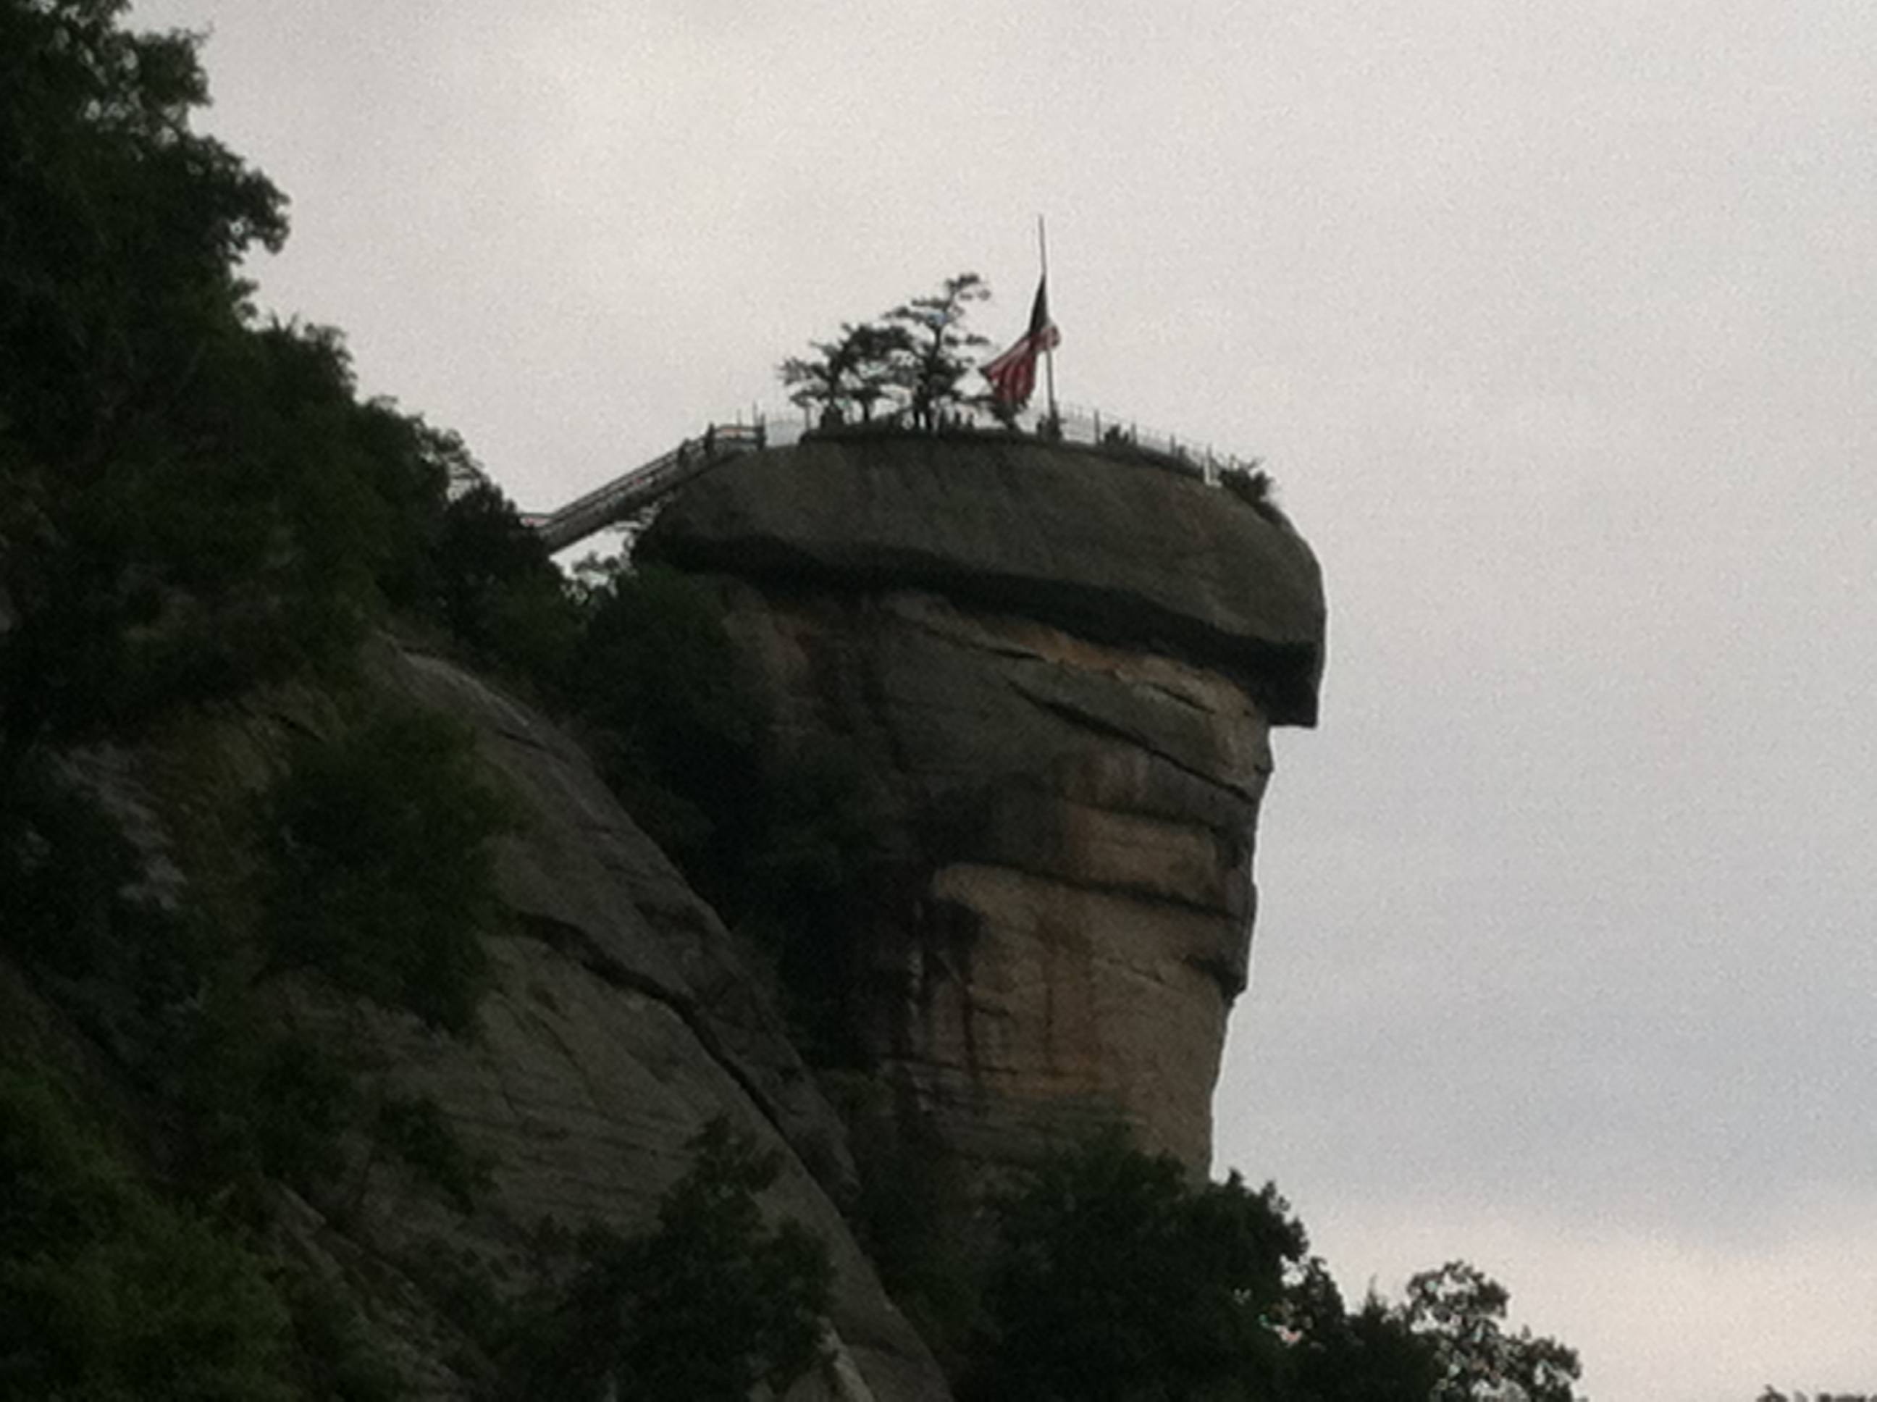
Mountains (Blue Ridge) Region
- These mountains are connected to the Appalachians (Eastern U.S.)
- Tallest mountain here is Mt. Mitchell (more than 6,600 feet high)
- Other mountains: Grandfather Mountain (Boone), and Chimney Rock (Rutherford Co.)
- The names “Blue Ridge” and “Great Smoky Mountains” come from the clouds of mist those mountains give with that color or texture
- Historically this was a tough place to navigate or travel due to the mountains, until the Blue Ridge Parkway was added in the 1930s
- Cities in the mountains: Asheville, Boone, Murphy, etc.
- People either farm with livestock, mine, or grow and sell christmas trees
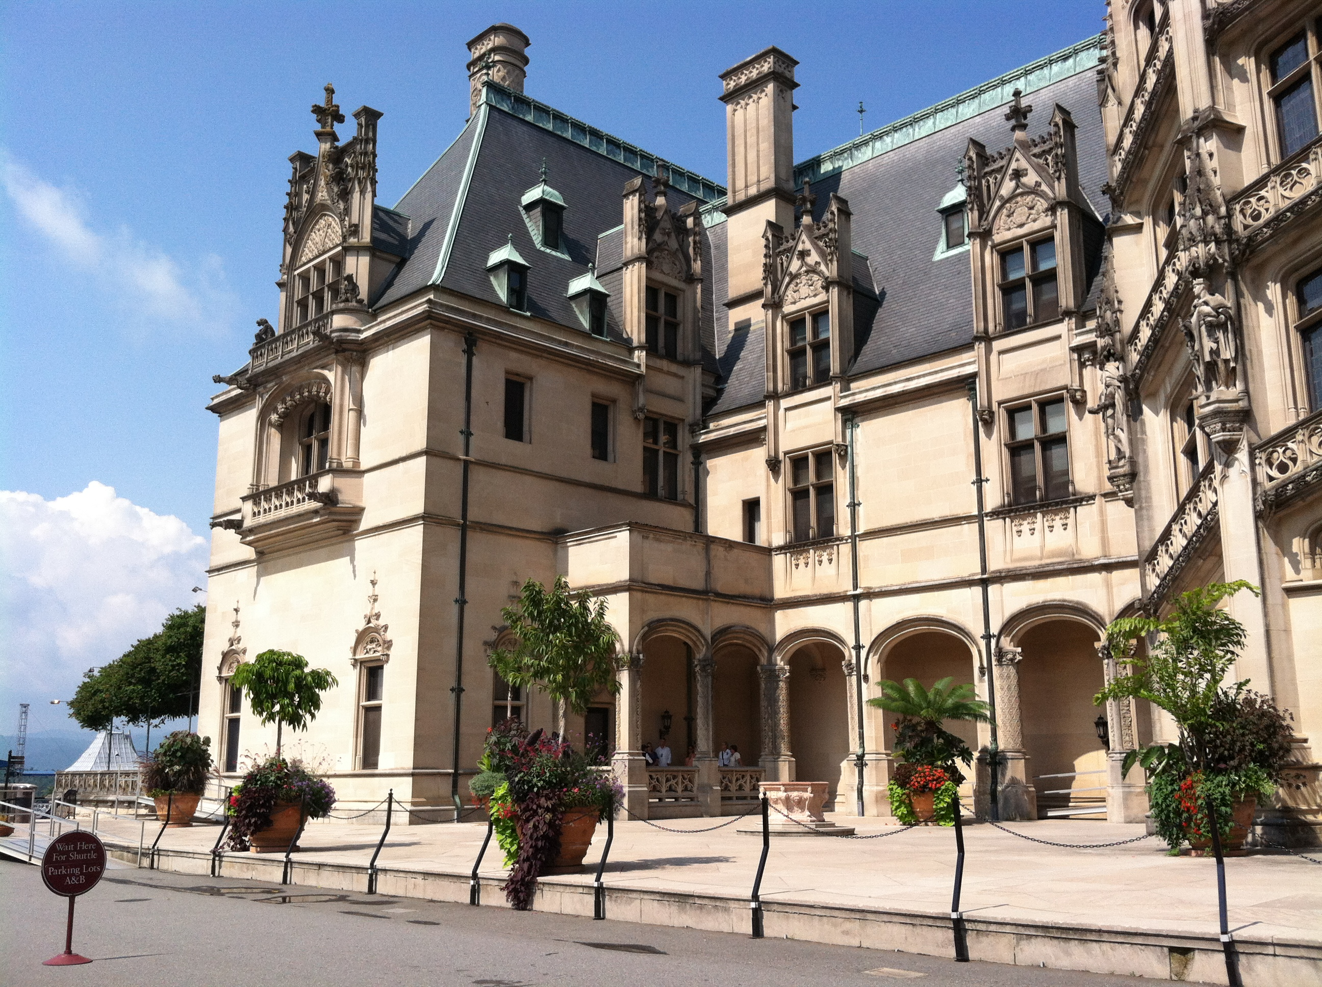
- Many movies (including the Hunger Games) were filmed in this region; tourism is also big (Biltmore Mansion is in Asheville)

