North Carolina Tidewater Region
- Tidewater-Eastern region of North Carolina; also known as the “Outer Coastal Plain,” it consists of beaches, wetlands and barrier islands
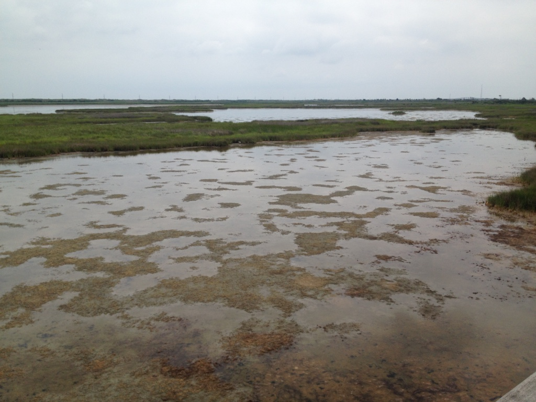
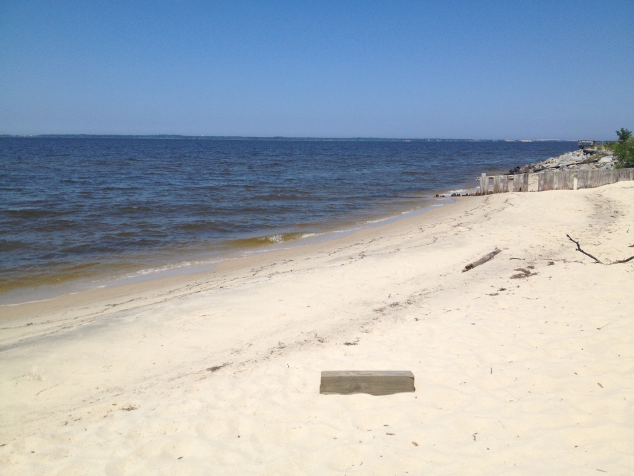
- Pictures below: 1. Swampland at Bodie Island. 2. Albemarle Sound, Manteo, NC

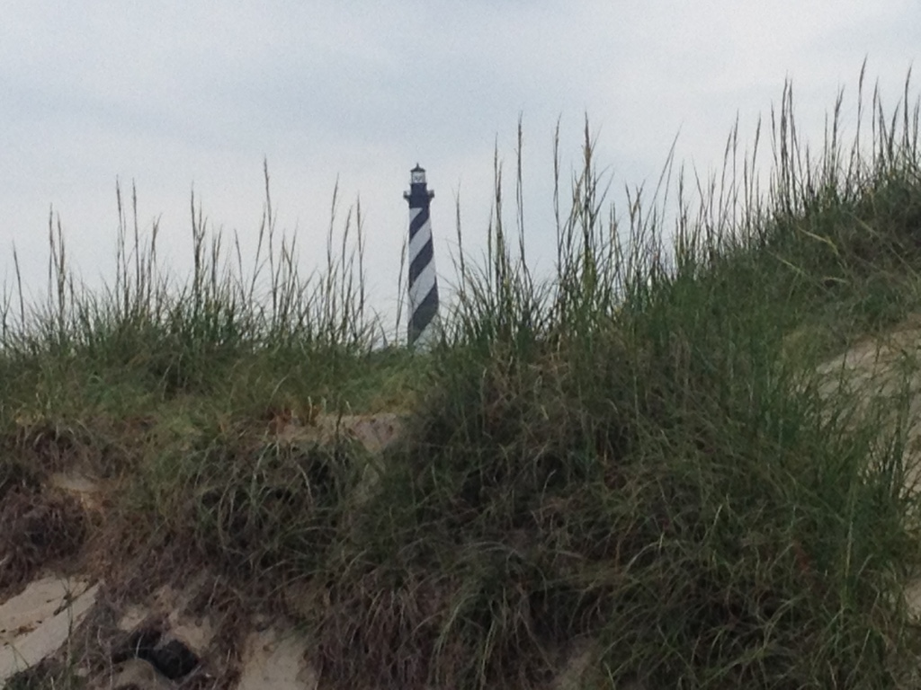
- Outer Banks-These barrier islands extend along the Albemarle and Pamlico Sound (West) and the Atlantic Ocean (East)
- Lack of inlets (openings for seawater to go in and out) and bumpy landforms make shipping tough
- Shoals, or unseen sandbars, have sunk hundreds of ships
- The OBX is called the “Graveyard of the Atlantic,” leading to lighthouses like Cape Hatteras
- Hurricane-a powerful tropical storm that brings high winds and heavy rains
- Notable places: Kitty Hawk, New Bern, Edenton, Manteo, Wilmington (this port city is known for shipping because there are no barrier islands)

