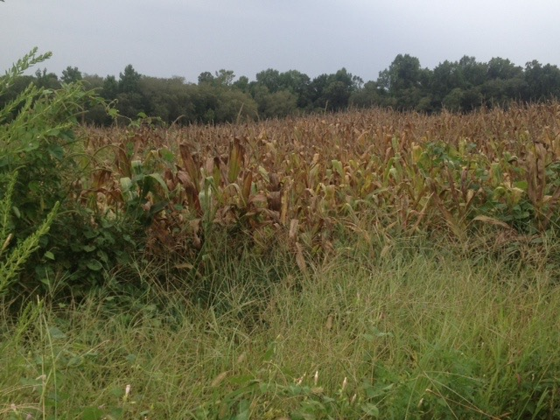
Inner Coastal Plain Region
- Inner Coastal Plain-flat region in North Carolina that has the state’s richest soil; farmers grow tobacco, cotton, corn, etc.—we live here!
- Known for its many crossroads hamlets, or very small communities with names like “Ballard’s Crossroads.”
- Cities like Goldsboro, Greenville, and Rocky Mount exist because of tobacco (“tobacco towns”)
- Longleaf pines grew all over this region, used for tar and lumber; now there are more loblolly pines
- Sandhills make up the Southwestern part of this region; since farming doesn’t work, golf courses and Ft. Bragg use the sand
- Cape Fear and Neuse rivers also run through this region
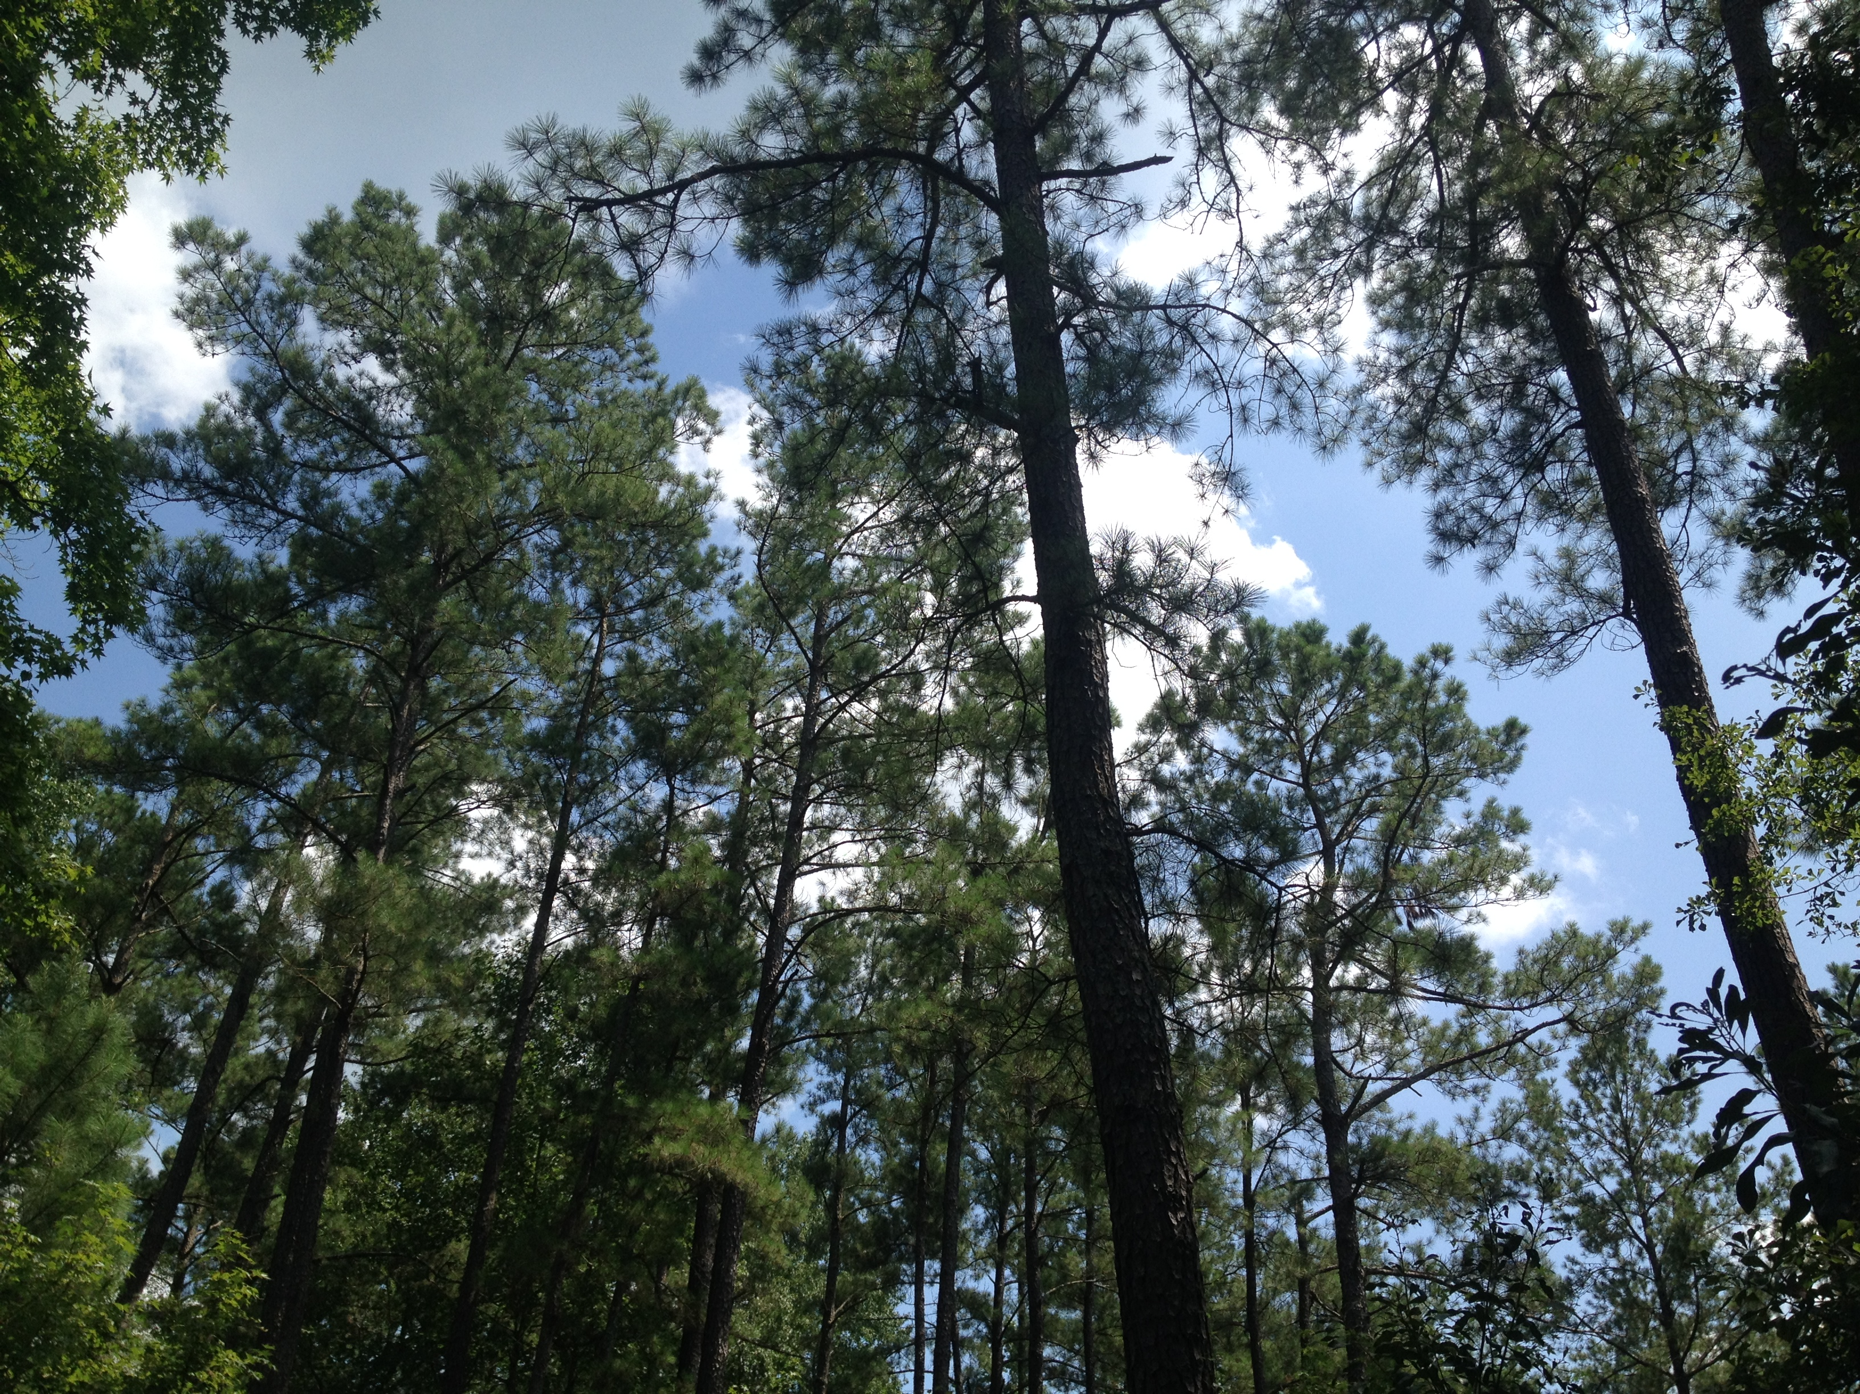
- Hog and poultry farms have outgrown tobacco farms, but N.C. is still the nation’s top producer of tobacco and sweet potatoes

