Jamestown, VA Colony-Guided Notes
Follow along as we watch videos or lecture/discuss the Jamestown colony. The key names and answers must be filled in the following blanks to complete the notes.

- Jamestown, VA was first established in ________________________ and named after ___________________________. This became the first permanent English settlement.

2. ________________________________ funded the colonization effort; they invested in settling the colony in hopes of finding _____________________________.

3. Settlers came ill-prepared as they struggled with food supply, unusually cold winters, and the ______________________________ Indians.

4. ______________________________ brought leadership to the colony as he made peace with ______________________________ and his daughter, __________________________.

5. This leader’s quote, “_____________________________” helped give the colony temporary strength. Settlers were forced to ____________________________ for a living.

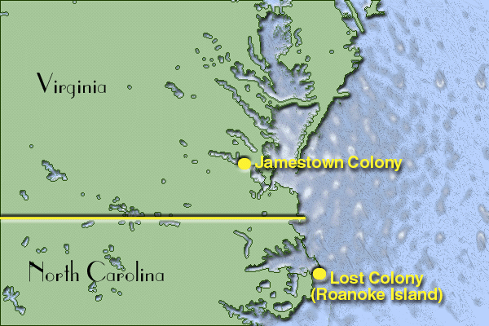
6.. Things were calmer in Jamestown until ________________________________ was forced to go home due to injury. ____________________________ became the colony’s governor.

7. Under this governor’s leadership, the settlers clashed with the Indians and were trapped inside their community. Many settlers died from illness or starvation in 1609-1610…this was called the “_________________________________.”

8. There were less than 100 settlers left, and had turned on each other. With the assistance of ______________________________ and _______________________________, the colony was rescued.

9. __________________________ introduced a new type of ______________________ from the West Indies that had a unique scent; settlers grew this and made this Jamestown’s big export. He also married __________________________, bringing longer peace.

10. _________________________ continued to grow and briefly became Virginia’s capital; it became _____________________________ in the late 1600s. Virginia also became a ___________________________________.

Map courtesy of totallyhistory.com

