French and Indian War Notes
- Also known as the ‘Seven Years’ War,’ the French and British continued centuries of fighting in North America (1754-63)
- France and England are now fighting over the Ohio River Valley, and each hope to control it
- The French take the lead first, with victories at Fort Necessity (against a young George Washington) and Fort William Henry (Gen. Montcalm wins)
- William Pitt of the British spends a lot of money to help his troops win the war, especially after Montreal
- Treaty of Paris 1763 ends the war, giving the British most of North America; King George III signs Proclamation of 1763 to keep the colonists out of Indian territory
- Importance? The British tax their colonists to pay off this war’s debt!

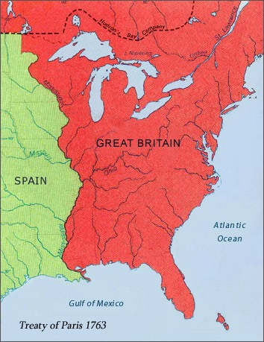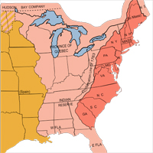
Treaty of Paris-1763 Proclamation Line of 1763

