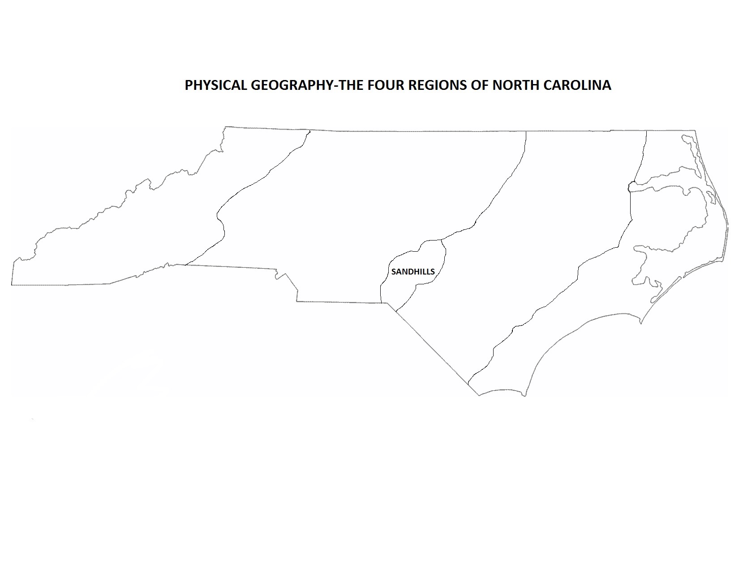
See other side of this paper for note-taking on these regions.

1. Outer Coastal Plain (Tidewater)

2. Inner Coastal Plain

3. Piedmont

4. Mountains
1. Outer Coastal Plain (Tidewater) | 2. Inner Coastal Plain | 3. Piedmont | 4. Mountains
Vocabulary words: Inlets, shoals, Albemarle Sound, Pamlico Sound, Atlantic Ocean, barrier islands, Neuse River, Cape Fear River, hurricane  Notes: Tidewater-Eastern region of North Carolina; also known as the “Outer Coastal Plain,” it consists of beaches, wetlands and barrier islands  - Outer Banks-These barrier islands extend along the Albemarle and Pamlico Sound (West) and the Atlantic Ocean (East)  - Lack of inlets (openings for seawater to go in and out) and bumpy landforms make shipping tough Shoals, or unseen sandbars, have sunk hundreds of ships  - The OBX is called the “Graveyard of the Atlantic,” leading to lighthouses like Cape Hatteras | Vocabulary words: ‘Tobacco towns,’ longleaf pines, loblolly pines, Neuse River, Cape Fear River  Notes: Inner Coastal Plain-flat region in North Carolina that has the state’s richest soil; farmers grow tobacco, cotton, corn, etc.—we live here!  - Cities like Goldsboro, Greenville, and Rocky Mount exist because of tobacco (“tobacco towns”)  - Longleaf pines grew all over this region, used for tar and lumber; now there are more loblolly pines  - Sandhills make up the Southwestern part of this region; since farming doesn’t work, golf courses and Ft. Bragg use the sand | Vocabulary words: Monadnock, Catawba River, Yadkin-Pee Dee River  Notes: Piedmont Region-An area known for its red clay and hilly locations, located at North Carolina’s center and is the most populated  - Two main rivers in the Piedmont: Catawba and the Yadkin Pee-Dee—one area of hills has a monadnock, or “last mountain standing” due to erosion (Pilot Mountain)  - There is occasional farming, but there are more livestock and dairy farms  - Tobacco manufacturing (Durham), textiles (Winston-Salem), and furni- | Vocabulary words: Blue Ridge, Mt. Mitchell, Biltmore, Appalachians (Mountains)  Notes: These mountains are connected to the Appalachians (Eastern U.S.)  - Tallest mountain here is Mt. Mitchell (more than 6,600 feet high)  - Historically this was a tough place to navigate or travel due to the mountains, until the Blue Ridge Parkway was added in the 1930s  - Cities in the mountains: Asheville, Boone, Murphy, etc.  - People either farm with livestock, mine, or grow and sell christmas trees  - see below for the last point
- Hurricane-a powerful tropical storm that brings high winds and heavy rains  - Notable places: Kitty Hawk, New Bern, Edenton, Manteo, Wilmington (this port city is known for shipping because there are no barrier islands) | - Hog and poultry farms have outgrown tobacco farms, but N.C. is still the nation’s top producer of tobacco and sweet potatoes | - -ture making (High Point) grew in the1800s; this state was once the nation’s leader in all three  - Despite lost manufacturing jobs, the region has recovered with banking (Bank of America), racing (NASCAR), and medicine (Research Triangle) | - Many movies (including the Hunger Games) were filmed in this region; tourism is also big (Biltmore Mansion is in Asheville)

