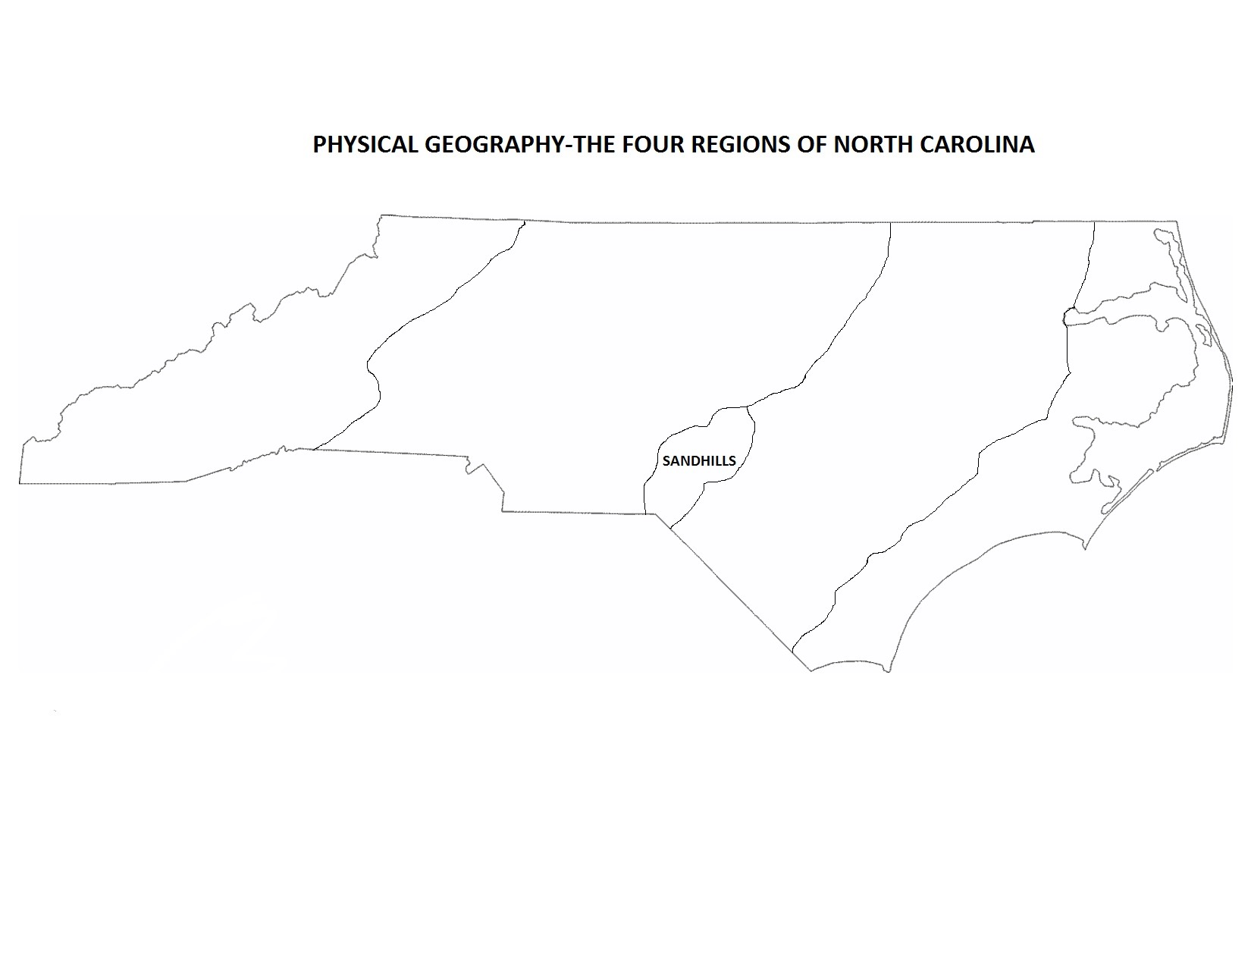
See other side of this paper for note-taking on these regions.
1. Outer Coastal Plain (Tidewater) | 2. Inner Coastal Plain | 3. Piedmont | 4. Mountains
Vocabulary words:  Notes: | Vocabulary words:  Notes: | Vocabulary words:  Notes: | Vocabulary words:  Notes:

