Blackbeard
- A former privateer from Bristol, England, Blackbeard, or “Edward Teach” or “Edward Thatch,” was known for robbing other ships
- He supposedly took off from home when he was young and became a privateer during a war with Spain/France
- Queen Anne allowed privateers to rob enemy ships and return their valuable goods (or “booty”)
- After the war ended, Blackbeard took to robbing ships as a pirate; he even blockaded Charleston, SC once
- He made peace with the North Carolina governor (Charles Eden) and lived in Bath, Outer Banks, etc.
- He was caught at Ocracoke Island in 1718 and killed by Royal Navy Lt. Robert Maynard from Virginia
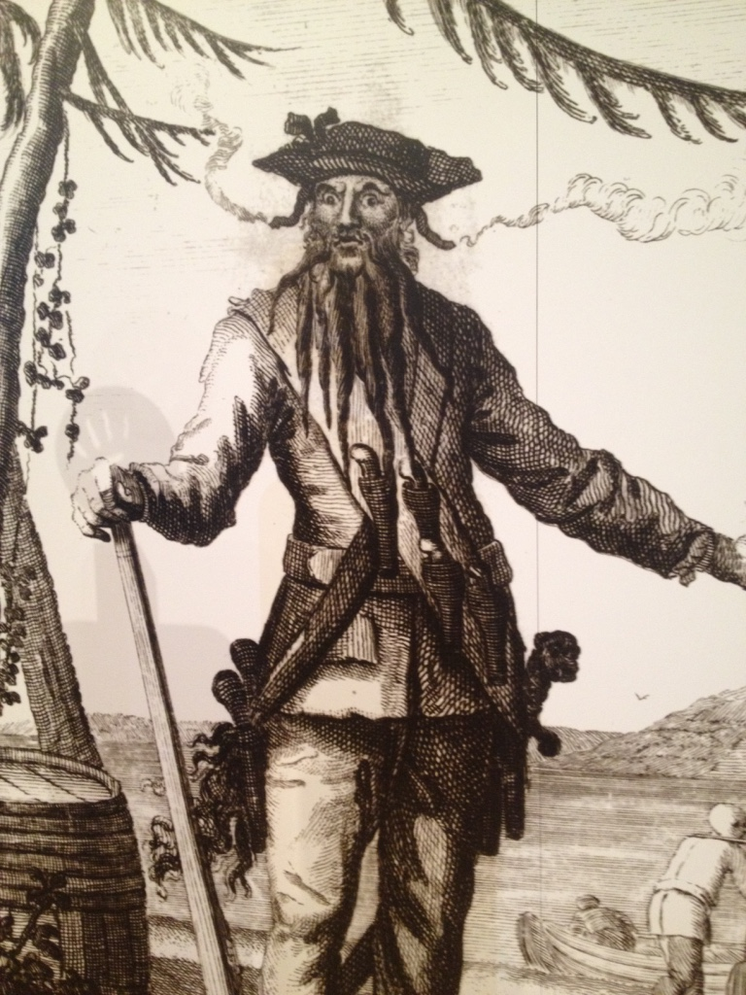
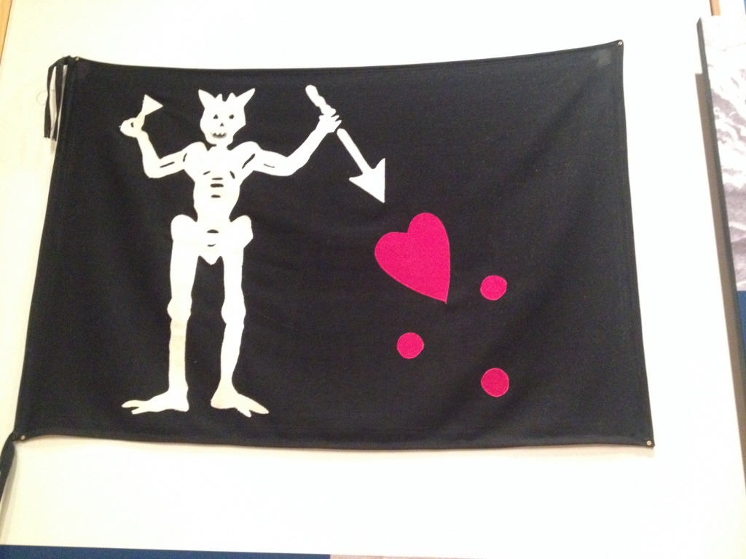
- His ship, Queen Anne’s Revenge, is being dug up (one step at a time) from the water near Beaufort Inlet
Thanks to the Museums in Manteo, NC for the photo opportunities!

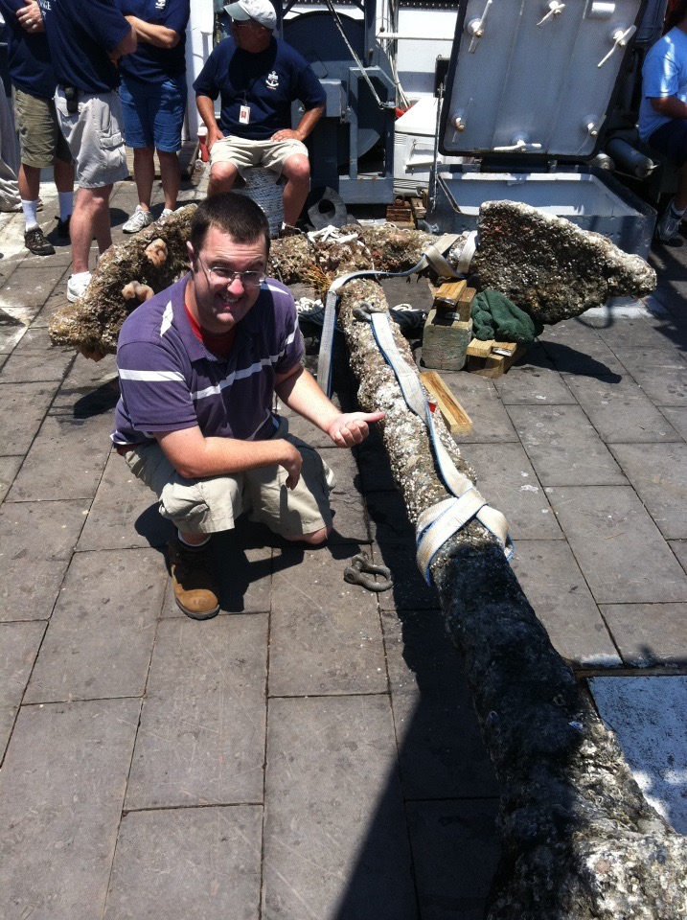

Mr. Groves with an anchor from Queen Anne’s Revenge

