1-30 to 2-02 Warm-Ups
Please answer the following questions. Each question is worth 4-5 points each.

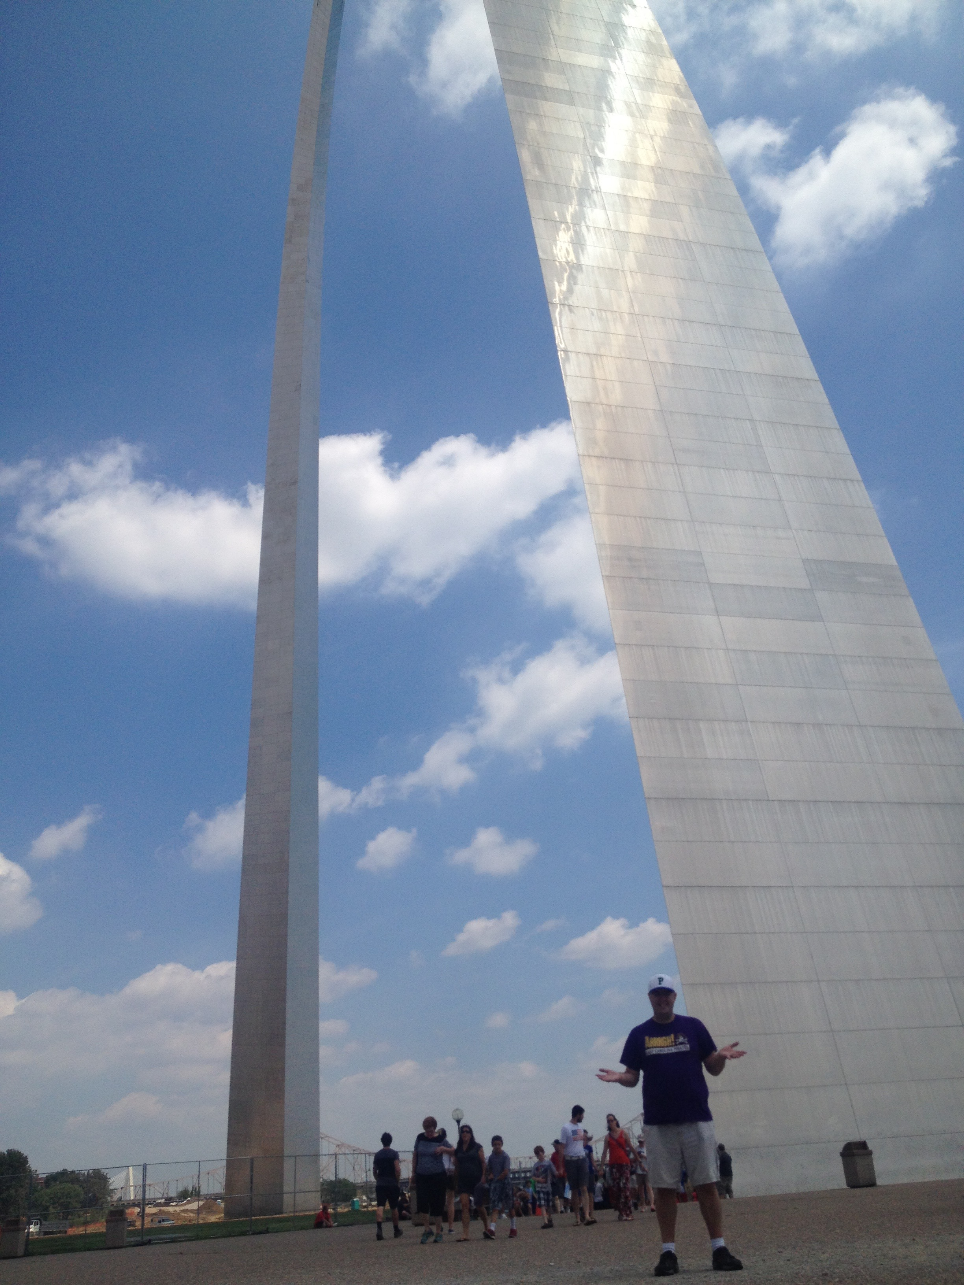
- Where in the is Mr.Groves?
In a one sentence, please describe where Mr. Groves is and why this spot is so significant.
________________________________________________________________________

Oh, say can you see  By the dawns early light  What so proudly we hailed  At the twilights last gleaming?  Who's broad striped and bright stars  Through the perilous fight  O'er the ramparts we watched  Were so gallantly streaming?  And the rocket's red glare!  The bombs bursting in air!  Gave proof through the night  That our flag was still there  Oh, say does that star spangled banner yet wave  O'er the land of the free  And the home of the brave? | ________________________________________________________________________________________________________________________________________________________________________________________________________________________________________________________________________________________________________________________________________________________________________________________________________________  ________________________________________________________________________________________________________________________________________________________________________________________________________
2. Please examine the ‘Star-Spangled Banner’ by Francis Scott Key. In four sentences, please summarize this poem based on the lesson, and use examples from the poem to justify it.

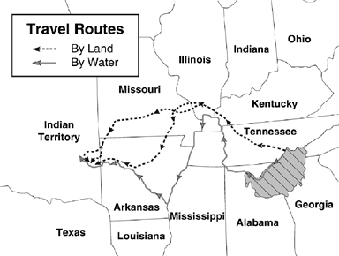
3. Please examine the Trail of Tears map below. Answer the questions afterwards. (Courtesy of Schoolnet)

- Where did most of the Cherokee start their journey, or was their former home? _______________________________________________________
- Name some of the states the Cherokee crossed, by land or water, to reach their new destination. _____________________________________________
- What present-day is considered part of the ‘Indian Territory’?_________________________
- What obstacles did these Cherokee likely face while traveling West?_________________________________________________________________________

4. Please correct the following sentences. Then, please re-write the sentences with these corrections as a small paragraph.

President George W. Bush was president when Canada bought land from France and it was called the “California Purchase” and later sent Lois and Clark to explore the land and they went with Pocahontas who helped them with their journey and they tried to reach the Atlantic Ocean for trade.

Da War uf 1821 luz da 1st time da U.S. deeeclared war on the French. Da Brazilian national anthem, da ‘Star-Spangled Fish,’ wuz created cuz….idk.

